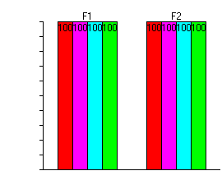
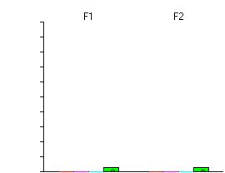
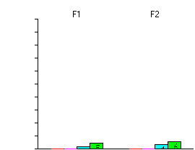
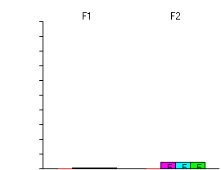
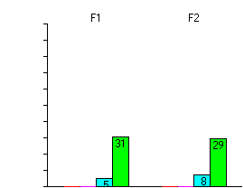
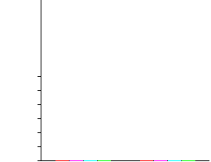
SEPI vs Sepi ICA comparison 1st Break SEPI vs Simo ICA comparison 1st Break

SEPI vs Kryz ICA comparison 1st Break SEPI vs Khalis ICA comparison 1st Break

Simon vs Kryz ICA comparison 1st Break Simon vs Khais ICA comparison 1st Break

Kryz vs Khalis ICA comparison 1st Break
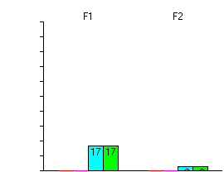

SEPI vs Sepi ICA comparison IQ SEPI vs Simo ICA comparison IQ
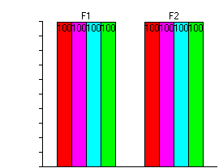
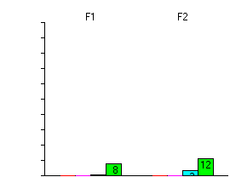
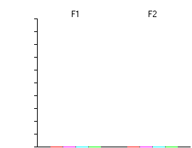
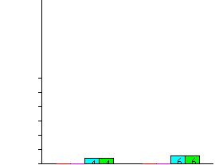
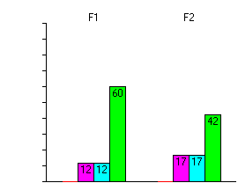

SEPI vs Kryz ICA comparison IQ SEPI vs Khalis ICA comparison IQ

Simon vs Kryz ICA comparison IQ Simon vs Khais ICA comparison IQ
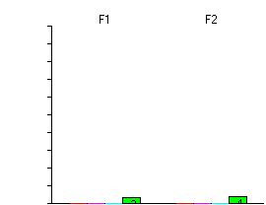

Kryz vs Khalis ICA comparison IQ
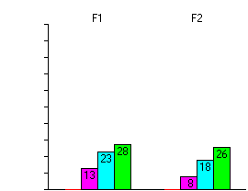

SEPI vs Sepi ICA comparison 2st Break SEPI vs Simo ICA comparison 2st Break
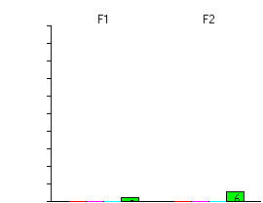

SEPI vs Kryz ICA comparison 2st Break SEPI vs Khalis ICA comparison 2st Break
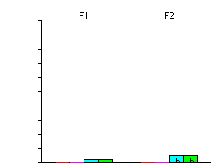

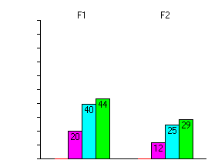
Simon vs Kryz ICA comparison 2st Break Simon vs Khais ICA comparison 2st Break

Kryz vs Khalis ICA comparison 2st Break

SEPI vs Sepi ICA comparison Passage SEPI vs Simo ICA comparison Passage
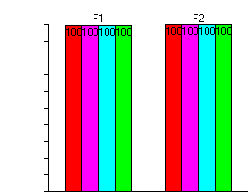
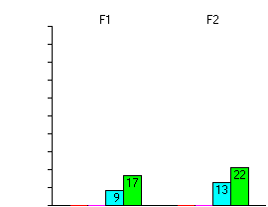
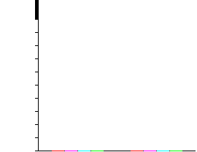
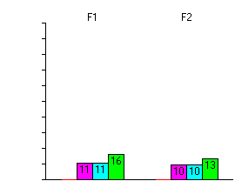

SEPI vs Kryz ICA comparison Passage SEPI vs Khalis ICA comparison Passage

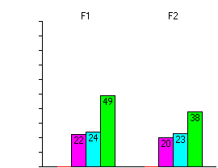
Simon vs Kryz ICA comparison Passage Simon vs Khais ICA comparison Passage
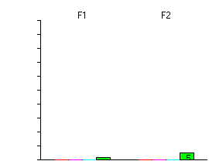

Kryz vs Khalis ICA comparison Passage

SEPI vs Sepi ICA comparison PassageQ SEPI vs Simo ICA comparison PassageQ
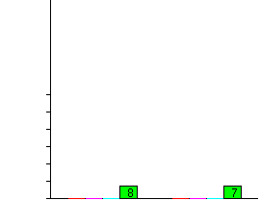
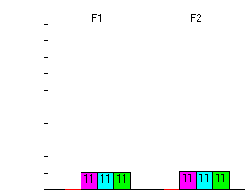

EPI vs Sepi ICA comparison PassageQ SEPI vs Simo ICA comparison PassageQ


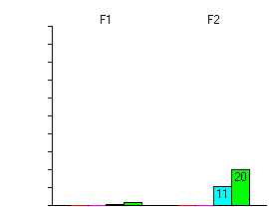
SEPI vs Sepi ICA comparison PassageQ SEPI vs Simo ICA comparison PassageQ

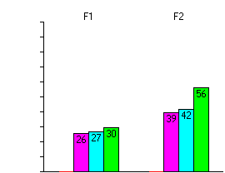

Kryz vs Khalis ICA comparison PassageQ

Sepi 1st Break vs break 2nd Simo 1st Break vs break 2nd
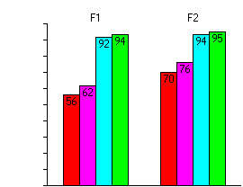
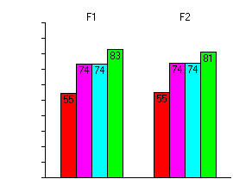

Kryz 1st Break vs break 2nd Khalis 1st Break vs break 2nd
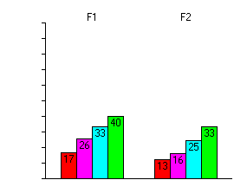
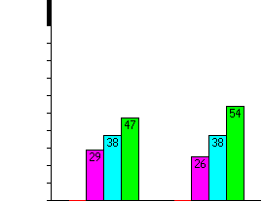

Sepi Passage vs Passage Question Simo Passage vs Passage Question
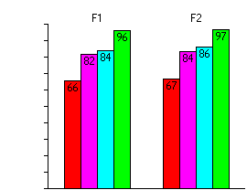
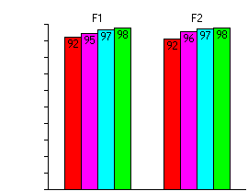

Kryz Passage vs Passage Question Khalis Passage vs Passage Question
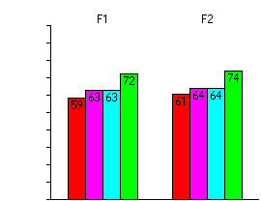
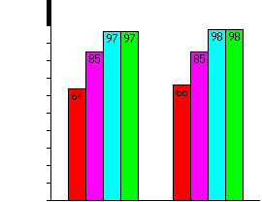

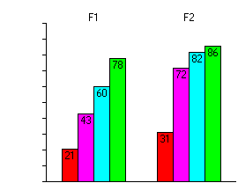
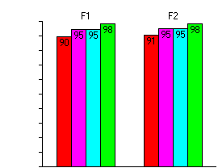
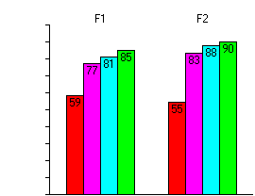
Sepi IQ vs Passage Simon IQ vs Passage

Kryz IQ vs Passage Khalis IQ vs Passage
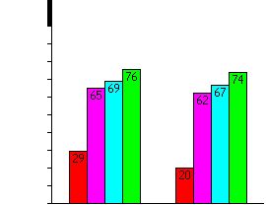

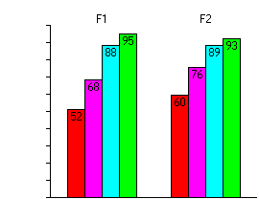
Sepi IQ vs Passage Question Simon IQ vs Passage Question
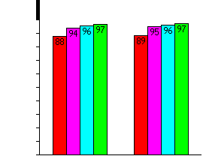

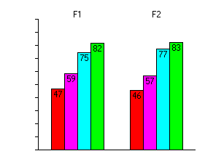
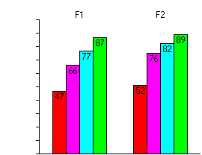
Sepi IQ vs Passage Question Simon IQ vs Passage Question

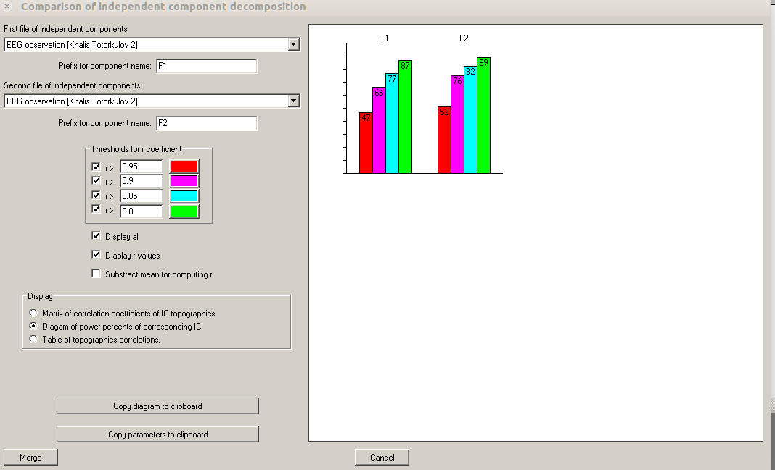
COMPARISON OFINDEPENDET COMPONENT DECOMPOSITION
- This Comparison is done using Wineeg after data is cleaned
- The title of the graph's are on the top of the plot
- When same observation are compared the values of the Bras get to 100
- So I am guessing the more similar they are the higher the value of the graph
- Place look throughly
- The tool bellow is the one I used for plotting this data
- PassageQ stands for passage Question

